**Installation Report: JDK and IntelliJ IDEA**

This report documents the installation process for the Java Development Kit (JDK) and the Integrated Development Environment (IDE) IntelliJ IDEA.

**Software versions used:**

* JDK: [ version ( 19.0.2)]
* Location of java in lp: C:\Program Files\Java\jdk-17\bin
* IntelliJ IDEA: [ downloaded IntelliJ IDEA version ( Community 2024.1)]
* Location: C:\Program Files\JetBrains\IntelliJ IDEA Community Edition 2024.1\bin

**Operating System:** r operating system ( Windows 10)]

**JDK Installation**

1. **Download the JDK:**
   * Oracle website (<https://www.oracle.com/java/technologies/downloads/>) and download JDK installer for operating system.
2. **Run the installer:**
   * downloaded installer file.
   * **Windows:**choose an installation directory. The default location is usually C:\Program Files\Java\jdk-<version>.
   * .

**IntelliJ IDEA Installation**

1. **Download IntelliJ IDEA:**
   * JetBrains website (<https://www.jetbrains.com/idea/download/>) and download IntelliJ IDEA Community Edition installer for operating system.
2. **Run the installer:**
   * downloaded installer file.
   * Follow the on-screen instructions to complete the installation.
   * **Windows:** choose an installation directory. The default location is usually C:\Program Files\JetBrains\IntelliJ IDEA <version>.
3. **Configure IntelliJ IDEA (Optional):**
   * During installation, you can choose to import settings from a previous IntelliJ IDEA installation or configure them manually (e.g., theme, plugins).
   * The IntelliJ IDEA welcome screen should be displayed.

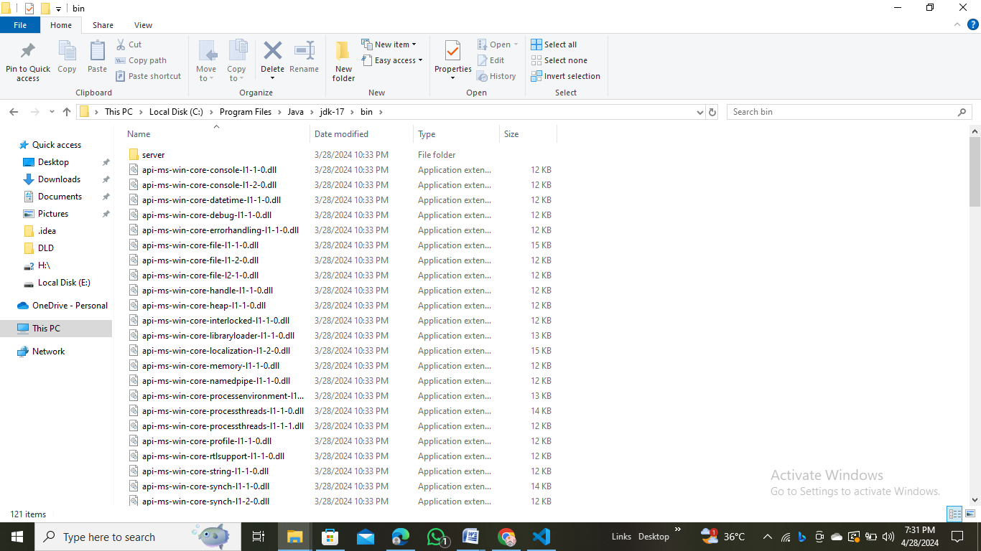

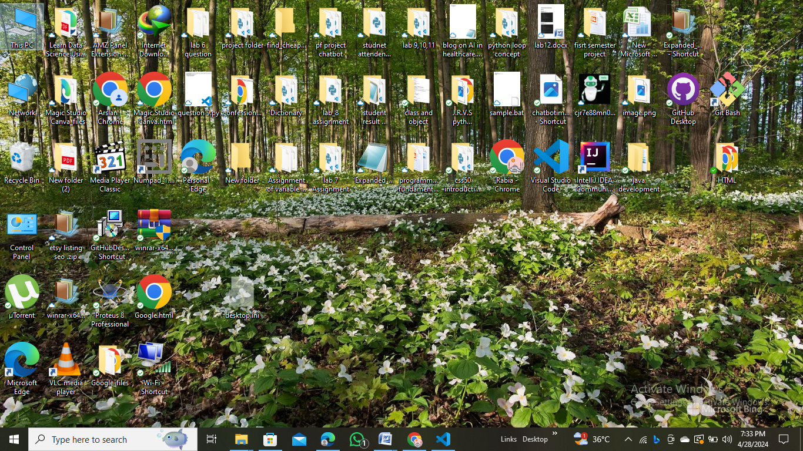

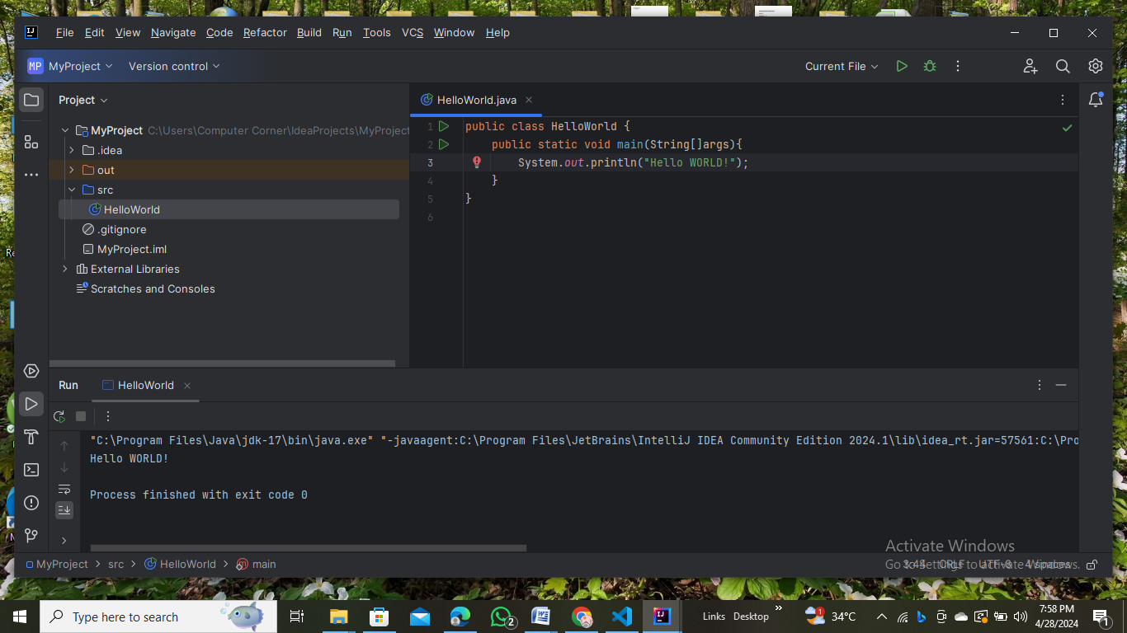

**1. public class HelloWorld {**

* public: This keyword declares that the class HelloWorld is accessible from any other code in the program.
* class: This keyword indicates that we are defining a class named HelloWorld. A class is a blueprint that defines the properties (variables) and behaviors (methods) of objects.

**2. }**

* This closing curly brace marks the end of the HelloWorld class definition. All the code within this block defines the members (variables and methods) of the class.

**3. public static void main(String[] args) {**

* public: Similar to the class declaration, this keyword makes the main method accessible from anywhere in the program.
* static: This keyword indicates that the main method is associated with the class itself, not any specific object of the class. We can call this method without creating an instance of the HelloWorld class.
* void: This keyword specifies that the main method doesn't return any value.
* main(String[] args): This is the signature of the main method, which is the entry point of a Java program.
  + String[] args: This parameter is an array of strings that can be used to pass command-line arguments to the program when it's run. In this example, we're not using the args parameter.

**4. System.out.println("Hello WORLD!");**

* System.out: This is a class that provides access to the system's console or standard output stream.
* out: This is a static field of the System class that represents the standard output stream.
* println: This is a method of the PrintStream class (which out belongs to) that prints a line of text to the console, followed by a newline character.
* "Hello WORLD!": This is the string literal that gets printed to the console.

**In summary:**

This code defines a class named HelloWorld with a single main method. The main method prints the message "Hello WORLD!" to the console when the program is executed